MIND TRACK PROJECT

A "Mind Track" project (focusing on monitoring, tracking, and analyzing data) can be implemented using Jenkins to create an automated, continuous pipeline. This ensures that data pipelines, code quality, and security vulnerabilities are continuously tracked and monitored.

1. Project Goal

To build a Jenkins pipeline that tracks the software development lifecycle (SDLC), automates testing, checks code quality, and monitors for vulnerabilities, providing real-time visibility into the project's health.

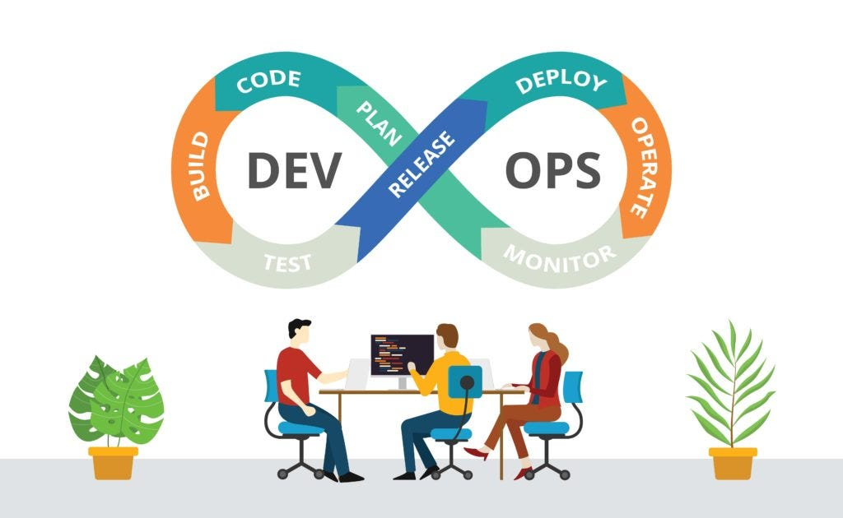

Jenkins is an extensible, open source continuous integration server. It builds and tests your software continuously and monitors the execution and status of remote jobs, making it easier for team members and users to regularly obtain the latest stable code.

This is a series of tutorials for Jenkins, Install and Configure, Automate the builds, CI/CD using Jenkins, Jenkins Pipeline as a Code, etc. This is a Part I Getting Started with Jenkins. We are talking of Devops build and release mechanism. You know the code starts right away from the development machine i.e. from your local machine and it must need some sort of version control in place to track the each and every change over a period of time. A Version Control System(VCS) keep individual’s code in a consistent way by managing the replicas over the change. So, your written code reach the centralized repository i.e. Source Code Management(SCM) using the Pull Request(PR) or some sort of merging technique. Git is widely used version control system in most of the projects. Once your codebase is ready it can go through different environments like development, staging and production. And, in between lot of configuration task need to be done i.e building a stuff, then deploying it, configuring softwares and tools, setting up the servers, monitoring and logging mechanism, prevention alerts, etc. The most of the task needs automation in place as it’s impossible to configure hundreds of thousands of machines manually. So, there is a need for better tool which will automate the build, test your system in staging and deploy it to production. Hudson was a very popular open source Continuous Integration(CI) tool developed by Sun Microsystems. Oracle brought the Sun Microsystem and then it started from this project named as Jenkins. So, Jenkins has become more popular over the last few years.

Jenkins is an extensible, open source continuous integration server. It builds and tests your software continuously and monitors the execution and status of remote jobs, making it easier for team members and users to regularly obtain the latest stable code.

Continuous Integration(CI) is a continuous process of of merging new code into the centralized repository. You can easily find the issues if there are any. The static code checking is perform in this process to catch the bugs earlier. The unit test plays the important role in this process to validate the code merge into the centralized repository. It is best practice to have a build server designed specifically for performing these tests so your development team can continue merging requests even while tests are being performed.

“Continuous Integration(CI) doesn’t get rid of bugs, but it does make them dramatically easier to find and remove” — Martin Fowler, Chief Scientist, ThoughtWorks.

Code changes made by individual team members are merged together into end-to-end working software, which we called as Integration phase. It’s hard work which often results in code conflicts, difficult to find bugs, code redundancies and and difficult to fix them which leads to software delivery delay. So, with this above approach in agile methodology, we can overcome all these difficulties as today’s businesses need new features to be incorporated into application with a day or week. This required the change of software delivery lifecycle.

Jenkins is the ultimate CI tool. It is a cross platform continuous integration application. Jenkins is used to build and test softwares continuously making it easier for developers to build software rapidly. It’s a plug and play as it can not do most work without respective plug-in’s. As continuous integration evolved, the industry created the notion of continuous delivery and continuous deployment to render production deployments a non-issue. These automated tools allow us to achieve checking code from your machine to deploying it into production system seamlessly.

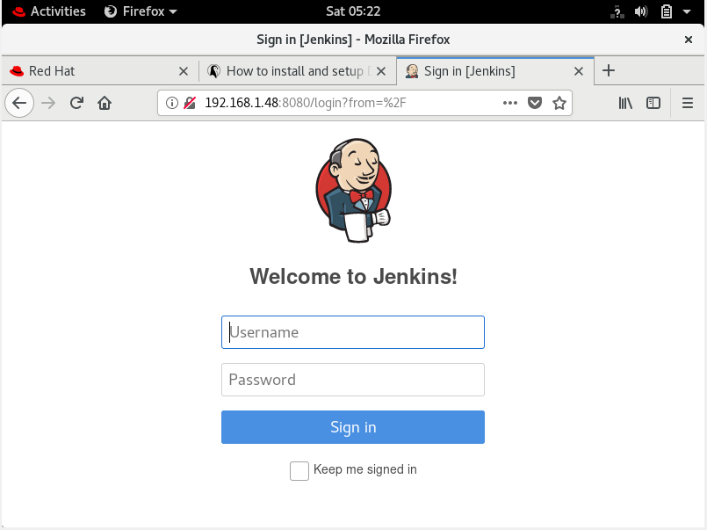

Objective
Setup up an infrastructure such as there are three teams/environments :

- Production Team
- Testing Team
- Quality Assurance Team

A working code is deployed by Production Team. Now a new product update comes and the developer creates a branch (dev1) from master node using git. QA team checks the code and merge both master and dev1 nodes. We have to automate this process using Jenkins

Requirements :
- Rhel 8- as a base for Docker
- Docker Image- http
- Git bash on Windows
- ngrok to create a tunnel for network to connect to IPs outside the private network
- Github and WebHooks

Process :

Operations Side:
My job 1 and job2 will get their code from the github (from their respective branches => master:production, dev:testing)

Both the containers have diferent web addresses so the quality team can monitor both

Quality team continously checks for changes in testing environemnt, and decides wether to approves it or not

On approval QA team manually builds the job3

Since job three is the upstream job of job2 and job1 , so on succesfull approval foloowong things will happen:

Dev and Master branch will be merged

Code will be pushed to the github

job 1 and job2 will be build

ngrok will be running in the system to provide public accessable addres so that github webhook will work and production site can be accessible to the public

STEPS:
Created a hook for post-commit and post-merge so the developer need not to be manually push the code every time he commits

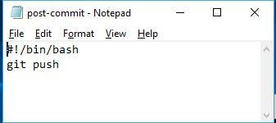

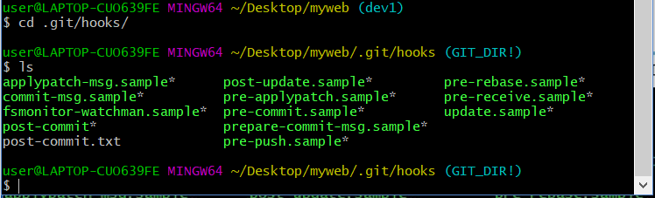

2. Added The webhooks to the Jenkins Github API :=> ip/github-webhook/

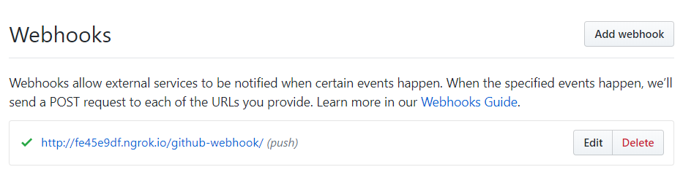

3. In Jenkins-

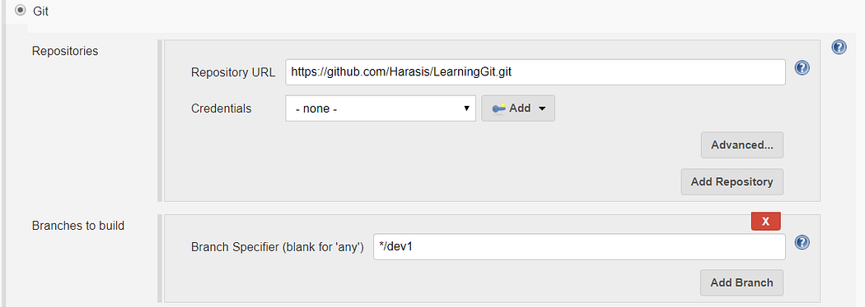

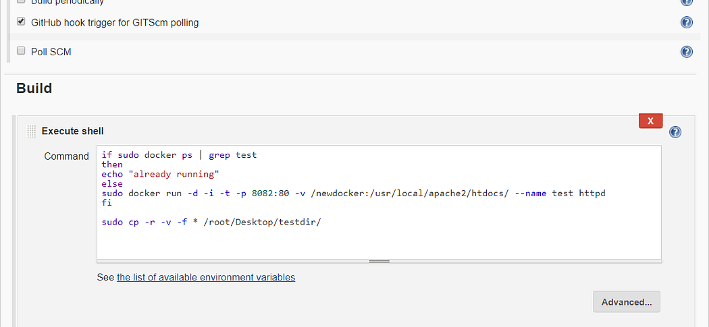

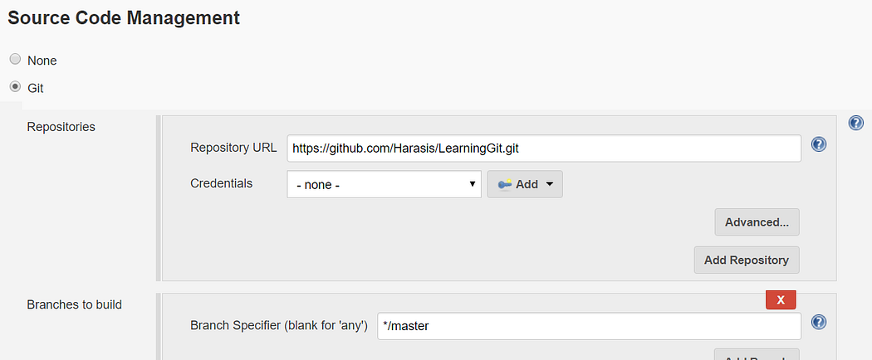

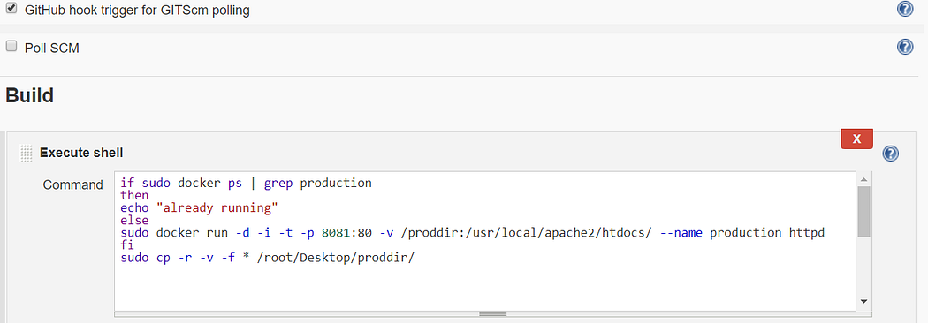

Job3 (to merge) configuration-

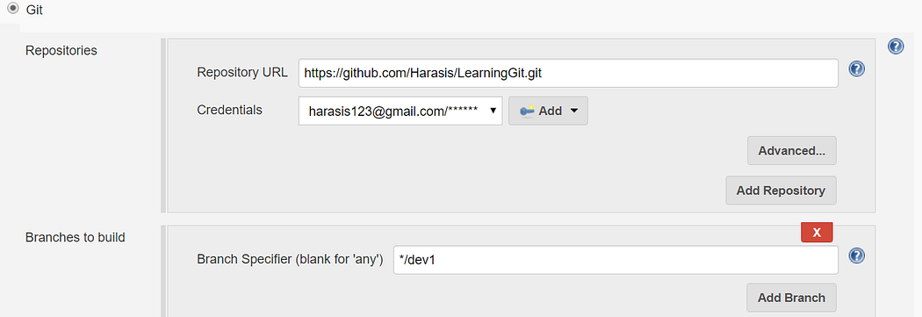

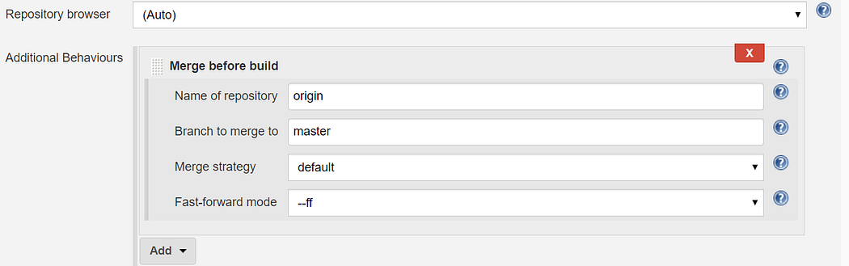

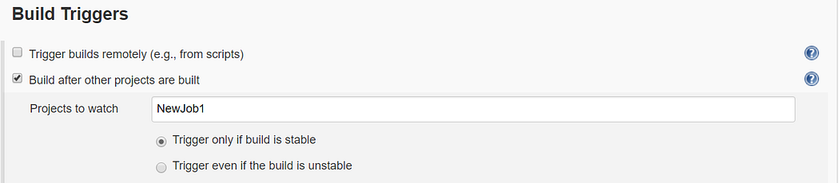

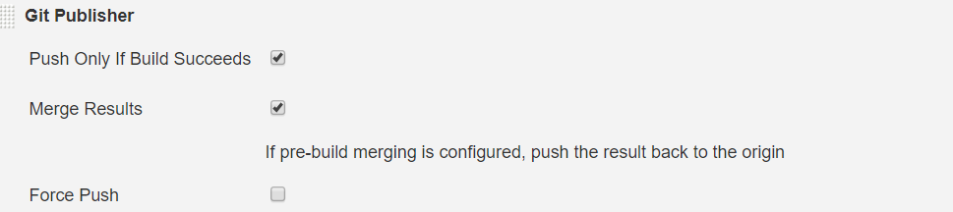

4. ngrok on rhel

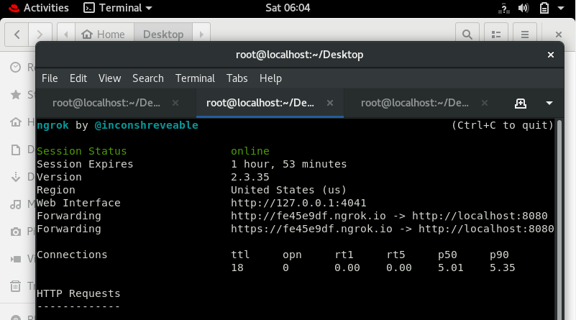

5. now we commit through developer and then job3 will automatically runs and merge both the master and branch(dev1)

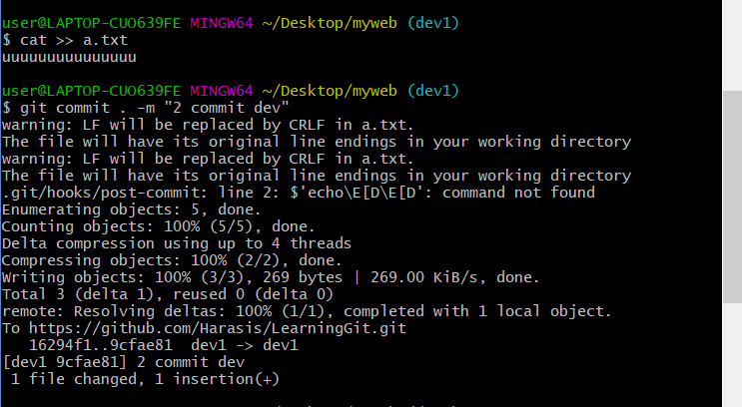

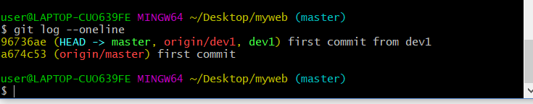

Diagram:

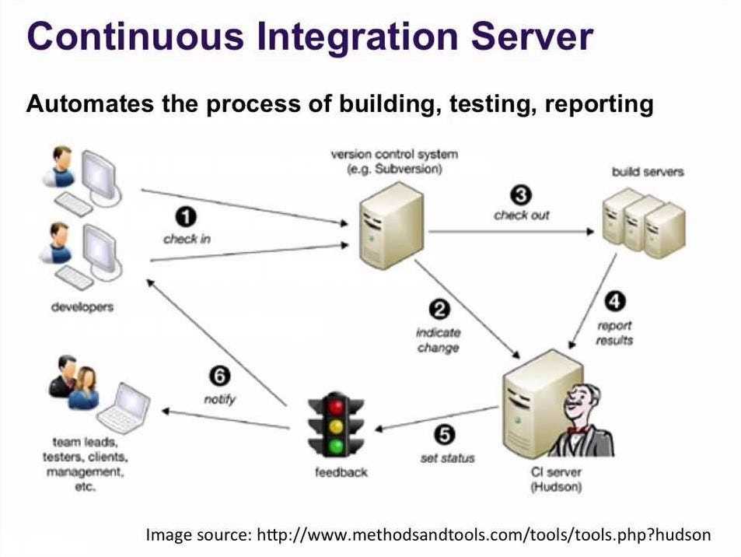

2. Core Components

Version Control (Git/GitHub): To track code changes.

Jenkins Controller: For orchestrating the automation workflow.

Docker: To provide isolated, reproducible build and test environments.

Dependency-Track (OWASP): To track component vulnerabilities and dependencies.

SonarQube: To track code quality and technical debt.

Dependency-Track

artifact : String

Specifies the artifact to upload. Dependency-Track supports uploading of CycloneDX bill-of-materials (BOM) formats.

synchronous : boolean

Synchronous publishing mode uploads a BOM to Dependency-Track and waits for Dependency-Track to process and return results. The results returned are identical to the auditable findings but exclude findings that have previously been suppressed. Analysis decisions and vulnerability details are included in the response.

This feature provides per-build results that display all finding details as well as interactive charts that display trending information.

Synchronous mode is possible with Dependency-Track v3.3.1 and higher.

autoCreateProjects : boolean (optional)

Enable auto creation of projects when authentication is enabled on Dependency-Track and the API key provided has the PROJECT_CREATION_UPLOAD permission.

dependencyTrackApiKey : String (optional)
When authentication is enabled on Dependency-Track, a valid API key will be required.

dependencyTrackConnectionTimeout : int (optional)
Defines the maximum number of seconds to wait for connecting to Dependency-Track. Use 0 to disable this timeout (means infinite wait).

dependencyTrackFrontendUrl : String (optional)
The alternative base URL to the Frontend of Dependency-Track v3 or higher. (i.e. http://hostname:port)

Use this if you run backend and frontend on different servers. If omitted, "Dependency-Track Backend URL" will be used instead.

dependencyTrackPollingInterval : int (optional)
Defines the number of seconds to wait between two checks for Dependency-Track to process a job (Synchronous Publishing Mode).

dependencyTrackPollingTimeout : int (optional)
Defines the maximum number of minutes to wait for Dependency-Track to process a job (Synchronous Publishing Mode). When the time is exceeded, the job will be aborted. The default value is 5 minutes.

dependencyTrackReadTimeout : int (optional)
Defines the maximum number of seconds to wait for Dependency-Track to respond. Use 0 to disable this timeout (means infinite wait).

dependencyTrackUrl : String (optional)
The base URL to Dependency-Track Backend (i.e. http://hostname:port)

failOnViolationFail : boolean (optional)
Marks the current build as unstable if there is at least one policy violation of severity failure.

This setting applies only to synchronous publishing mode!

failedNewCritical : int (optional)

failedNewHigh : int (optional)

failedNewLow : int (optional)

failedNewMedium : int (optional)

failedNewUnassigned : int (optional)

failedTotalCritical : int (optional)

failedTotalHigh : int (optional)

failedTotalLow : int (optional)

failedTotalMedium : int (optional)

failedTotalUnassigned : int (optional)
overrideGlobals : boolean (optional)

Allows to override global settings for "Auto Create Projects", "Dependency-Track URL", "Dependency-Track Frontend URL" and "API key".

Can be ignored in pipelines, just set the properties dependencyTrackUrl, dependencyTrackFrontendUrl, dependencyTrackApiKey and autoCreateProjects as needed.

projectId : String (optional)

Specifies the unique Project ID of the project to upload scan results to.

If the list of projects are not displayed (such as an HTTP 403 response), ensure the API key specified in the global configuration has VIEW_PORTFOLIO permission in addition to BOM_UPLOAD and/or SCAN_UPLOAD. Permissions are defined in Dependency-Track.

projectName : String (optional)
Specifies the name of the project for automatic creation of project during the upload process.

This is an alternative to specifying the unique UUID. It must be used together with a project version.

Ensure the API key specified in the global configuration has PROJECT_CREATION_UPLOAD permission and that you have enabled Auto Create Projects.

The value can contain environment variables in the form of ${VARIABLE_NAME} which are resolved.

projectProperties (optional)
Set additional properties for the given project.

The API key provided requires the PORTFOLIO_MANAGEMENT permission to use this feature!

3. Implementation Steps

A. Setup and Integration

Install Jenkins: Set up Jenkins using Docker, ensuring persistence for tracking data (using -v jenkins_home:/var/jenkins_home).
Install Plugins: Install essential plugins via Manage Jenkins -> Manage Plugins:

Git Plugin

Pipeline Plugin

Docker Pipeline Plugin

Dependency-Track Plugin

SonarQube Scanner Plugin

Configure Credentials: Add GitHub and SonarQube credentials to Jenkins.

Every time someone opens a PR to your repo, you ask them to run those jobs, take screenshots of the results, and paste these screenshots to the PR description as a proof of quality.

That’s too much waiting and too many keystrokes. People want automation: when they create a PR (or push a commit), those jobs should start to build. When the builds are done, the results should be conveniently visible at the "Checks" section at the bottom of the PR, like this:

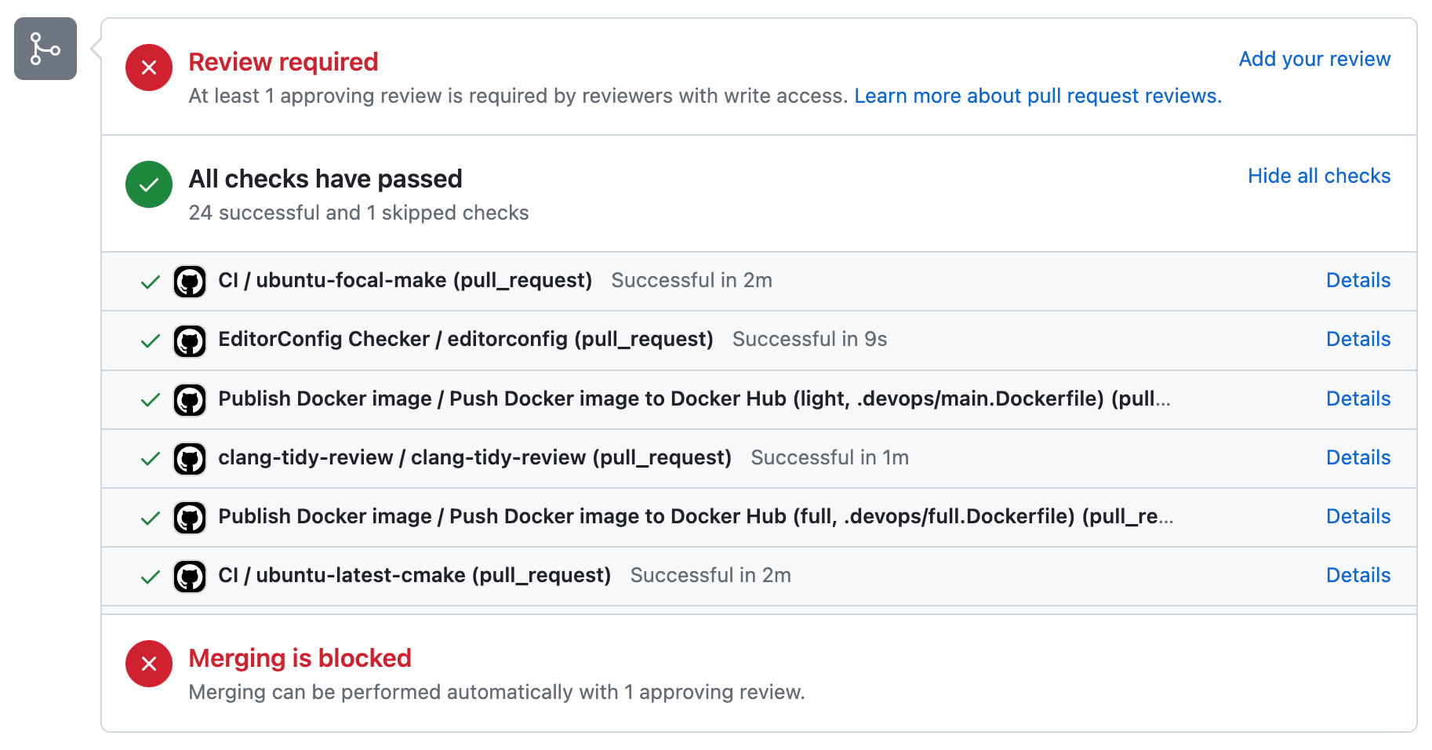

Ways to publish checks to PRs: Statuses, Checks, and Actions

Statuses, or as I’d like to call them, Commit Checks. They are associated with commits, not PRs. This means you can run them even without creating a PR

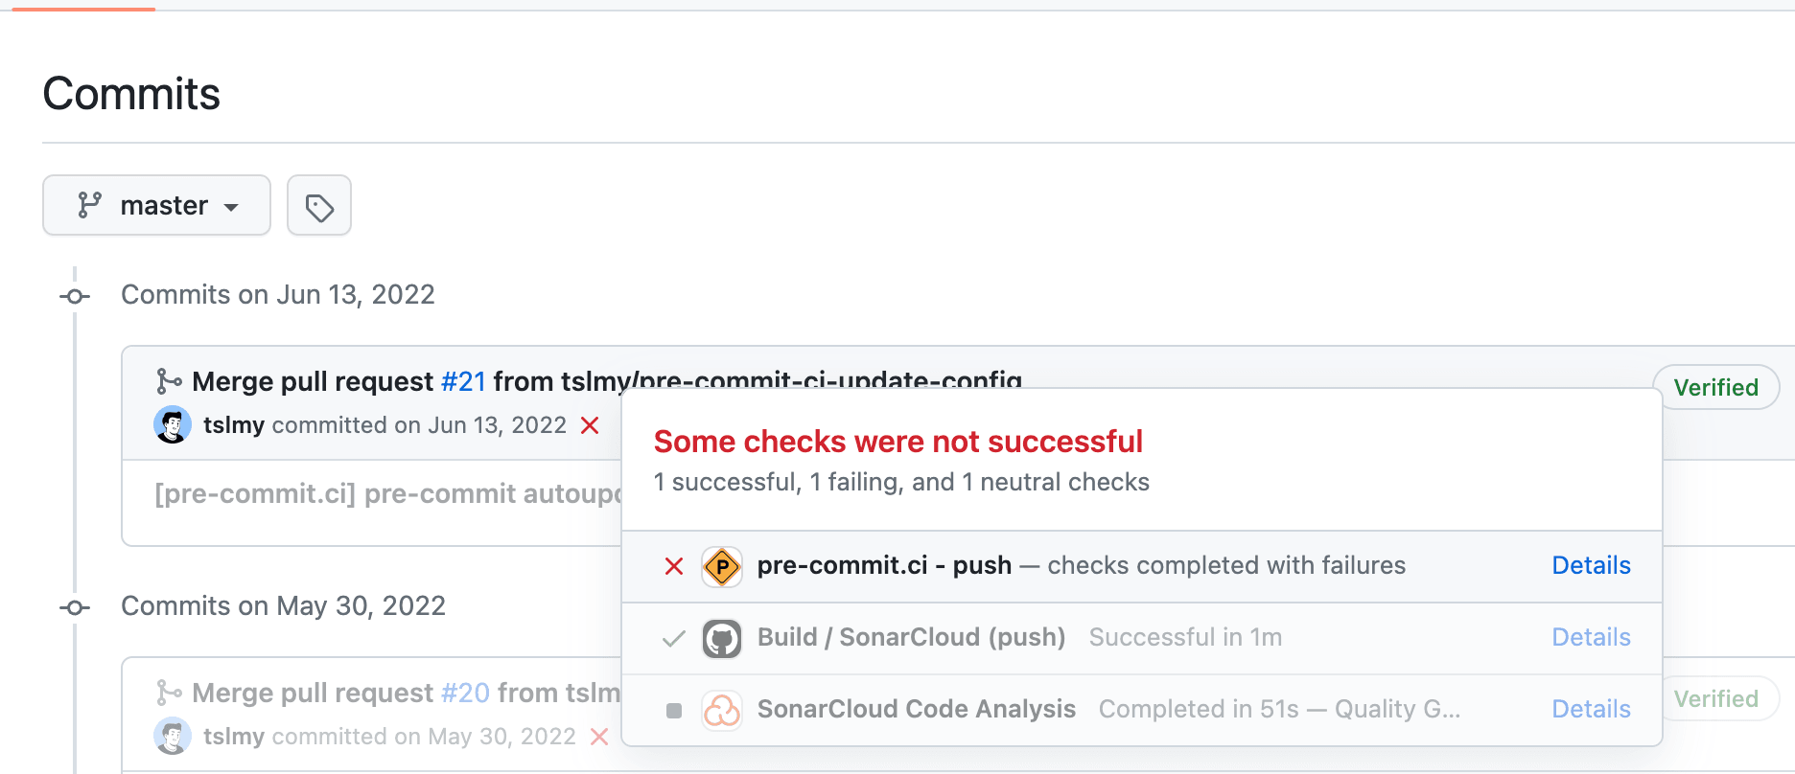

Checks, or more explicitly, PR Checks. These are run on commits but are stored with the PRs. With them, you can write long essays of messages to the "Checks" tab of a PR, but they do require authenticating as a GitHub App instead of a user, so it’s more complicated to set up. SonarCloud, a code analyzer, makes use of PR Checks via their namesake GitHub App. If you look closer, their report is just Markdown:

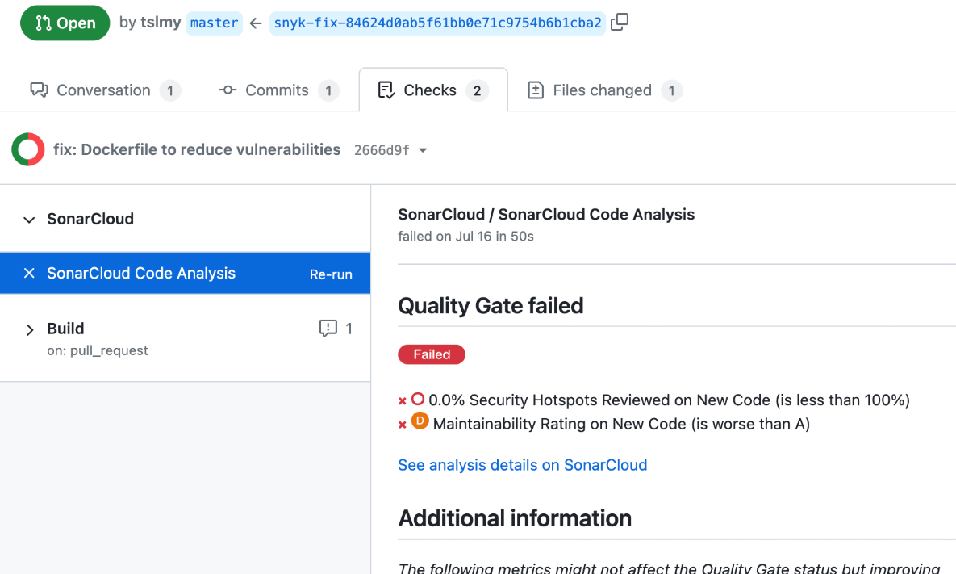

GitHub Actions (GA). GA is a different kind of CI system from Jenkins. Since this article is about Jenkins only, GA is only mentioned here for the sake of completeness.

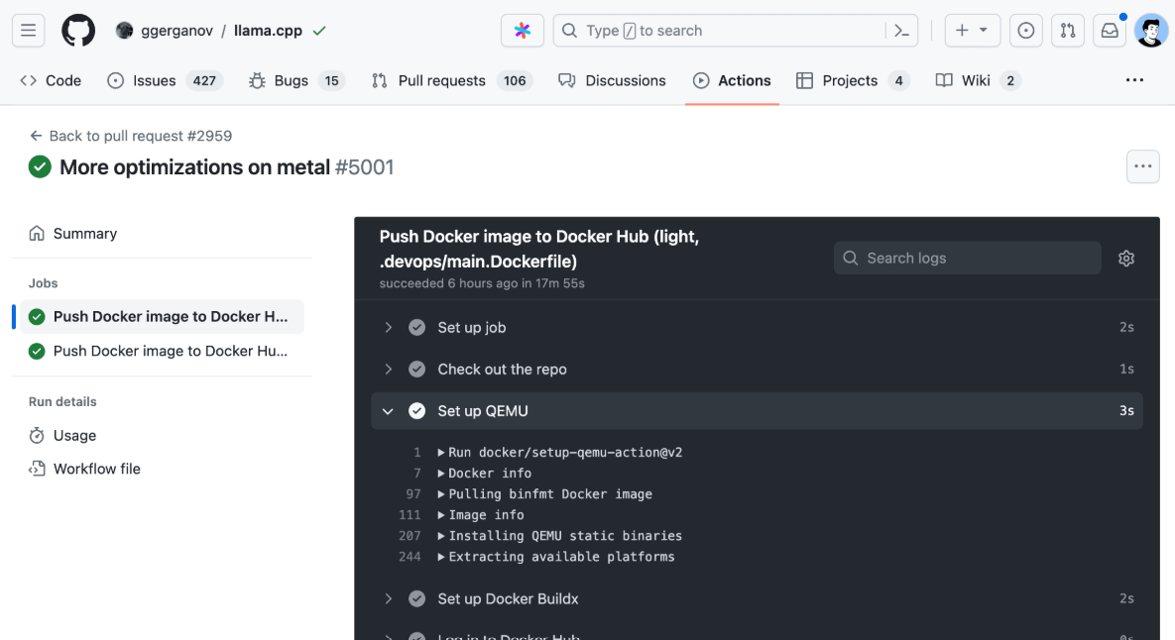

When the result is simple: Use commit statuses

The Jenkins jobs you want to trigger only run for a couple of seconds. Each only emits a simple result: pass or fail. You don’t need fancy reports, so commit statuses seem to be a suitable choice.

You installed the GitHub plugin to your Jenkins server and followed this guide to set it up. You are now able to emit simple one-liners as checks like this:

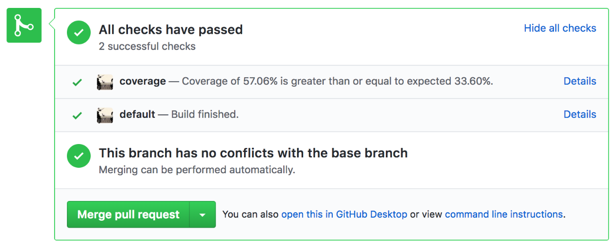

The plugin publishes to the PR only thrice: upon getting queued, upon the start, and upon completion. Your job actually has many time-consuming stages, such as building a manifest, deploying to staging, and running tests. These stages are often packed in a single script and you want to be notified at each stage.

The messages show up with your GitHub profile image as the icon, because Jenkins is using your PAT! You want to shy away from the spotlight, maybe because you don’t want to be mistaken by your less-GitHub-savvy collaborators as a ruthless robot critiquing (and blocking) everybody’s PRs.

When the report is long: Use PR checks

Your job generates a long report at the end, but the Checks section can only accommodate a couple of words. You have been rendering the reports as HTML and attaching them to the Jenkins builds themselves (perhaps with a nice Jinja2 template and the HTML Publisher plugin). The commit statuses your job writes to PRs contain links to the Jenkins builds themselves, so it’s only two clicks away from an HTML report — not bad.

To prevent past HTML reports from saturating the disk, you configured the job to only keep the 20 most recent builds. Then the team grew and people started complaining that their reports are getting purged before they could even take a look. You now have a scalability problem.

Checks API Plugin: This enables Jenkins to talk to the Checks API on various git hosting platforms, including GitHub, GitLab, and BitBucket. This is a base plugin that is meant to be extended with other plugins, not directly used by Jenkins jobs, though.

GitHub Checks API Plugin: This enables Jenkins to talk to GitHub specifically. It extends the aforementioned Checks API Plugin.

JUnit Plugin: This publishes JUnit-style XML test reports to various destinations. It posts to the current build, and — when the Checks API Plugin is available — publishes to GitHub/GitLab/…​as PR Checks.

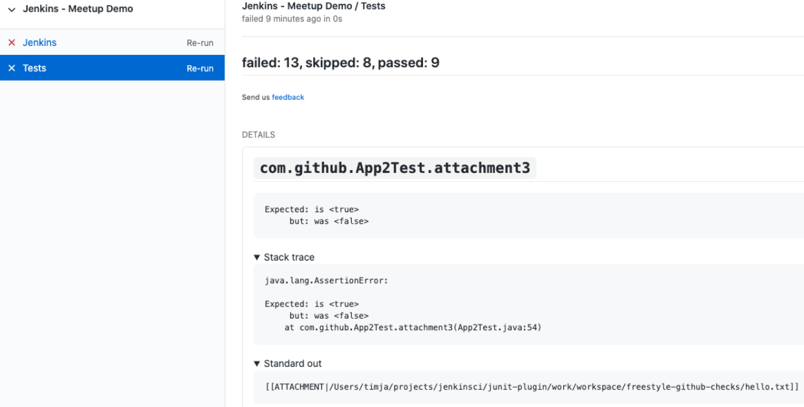

MIND TRACK PROJECT :

# Jenkins CI/CD Pipeline with Docker and GitHub

This repository demonstrates a Jenkins pipeline implementation for achieving continuous integration and continuous deployment (CI/CD) using Docker and GitHub.

## Introduction

The CI/CD pipeline provided here allows you to automate the process of building, testing, and deploying your application whenever changes are pushed to the GitHub repository. Jenkins, an open-source automation server, is used as the orchestrator for the pipeline. Docker, a popular containerization platform, is utilized to manage the deployment process.

## Prerequisites

Before setting up the pipeline, ensure that you have the following prerequisites:

1. An Amazon EC2 Linux machine with Jenkins, Git, and Docker installed.
2. A GitHub repository containing your application code and Dockerfile.

## Project Pipeline Flowchart

The CI/CD pipeline workflow is represented as follows:

![Jenkins CI_CD Pipeline with Docker and GitHub](https://github.com/harshartz/Jenkins-CI-CD-Pipeline-with-Docker-and-GitHub/assets/130890384/ab868d34-cfc4-4079-95b8-0b584622add5)

## Installation Instructions

### Installing Jenkins

To install Jenkins, follow these steps:

1. Ensure that your software packages are up to date on your instance by using the following command to perform a quick software update:
```bash
sudo yum update –y
```

2. Add the Jenkins repository using the following command:
```bash
sudo wget -O /etc/yum.repos.d/jenkins.repo \
https://pkg.jenkins.io/redhat-stable/jenkins.repo
```

3. Import a key file from Jenkins-CI to enable installation from the package:
```bash
sudo rpm --import https://pkg.jenkins.io/redhat-stable/jenkins.io-2023.key
```

4. Upgrade the system packages:
```bash
sudo yum upgrade
```

5. Install Java (Amazon Linux 2):
```bash
sudo amazon-linux-extras install java-openjdk11 -y
```

Install Java (Amazon Linux 2023):
```bash
sudo dnf install java-11-amazon-corretto -y
```

6. Install Jenkins:
```bash
sudo yum install jenkins -y
```

7. Enable the Jenkins service to start at boot:
```bash
sudo systemctl enable jenkins
```

8. Start Jenkins as a service:
```bash
sudo systemctl start jenkins
```

9. You can check the status of the Jenkins service using the command:
```bash
sudo systemctl status jenkins
```
### Installing Docker

To install Docker, follow these steps:

1. Install Docker:
```bash
sudo yum install docker -y
```

2. Enable Docker to start on system boot:
```bash
sudo systemctl enable docker
```

3. Start the Docker service:
```bash
sudo systemctl start docker
```

### Installing Git

To install Git, follow these steps:

1. Install Git:
```bash
sudo yum install git -y
```

### Additional Configuration

To allow Jenkins to interact with Docker, execute the following command:

```bash
sudo usermod -aG docker jenkins
```
After executing the above command, restart Jenkins:

```bash
sudo systemctl restart jenkins
```

## Pipeline Overview

The Jenkins pipeline is triggered by a webhook configured on the GitHub repository. Whenever a developer pushes changes to the repository, the pipeline is initiated, and the following steps are executed:

1. The pipeline checks if there is a running Docker container for the application.
2. If a container is running, the pipeline copies the updated files from the Jenkins workspace to the running container, ensuring the changes are immediately reflected.
3. If no running container is found, the pipeline builds a new Docker image using the code from the GitHub repository and deploys it as a new container on the Amazon EC2 Linux machine.
4. The deployed application can then be accessed on the target machine through the specified port.

## Getting Started

To get started with this CI/CD pipeline, follow the steps below:

1. Set up Jenkins, Git, and Docker on your machine.
2. Provide Jenkins with a GitHub credential (token):
- Generate a GitHub personal access token with the appropriate scopes (repo, webhook, etc.).
- In Jenkins, go to "Manage Jenkins" > "Manage Credentials"> "Global credentials (unrestricted)".
- Add a new credential of type "Secret text" or "Secret file" and enter your GitHub token.
- Save the credential.
3. Configure Jenkins by accessing its web interface.
4. Create a new Jenkins job and configure it as follows:
- Set the job type to "Freestyle Project".
- Connect it to your GitHub repository (https://github.com/harshartz/Jenkins-project.git) and configure the webhook.
- Select "GitHub hook trigger for GITScm polling" as the build trigger.
- Add an "Execute Shell" build step to the pipeline and use the following code:
```bash
#!/bin/bash

container_id=$(docker ps --filter "status=running" --format "{{.ID}}")

if [ -n "$container_id" ]; then
docker cp /var/lib/jenkins/workspace/devops-project/. "$container_id":/usr/share/nginx/html
else
docker build -t server /var/lib/jenkins/workspace/devops-project
docker run -d -p 9090:80 server
fi
```
Run the Jenkins job and verify the successful execution of the pipeline.

![Screenshot (11)](https://github.com/harshartz/Jenkins-project/assets/130890384/1ffd9035-951d-4ced-89a2-84b6c5c7f6e0)

*Application is running, and whenever a developer commits changes to the GitHub repository, it will automatically get deployed to the application.*

